Water Rights and Social Protest:
Politics, Governance, and the Meanings of Access

The following syllabus is designed as a template for scholars, students, and anyone interested in water and water rights. Each week is framed around a specific theme and includes a set of suggested readings. We hope readers will find the sources below useful for understanding the meanings—both historical and current—of water rights and water access.

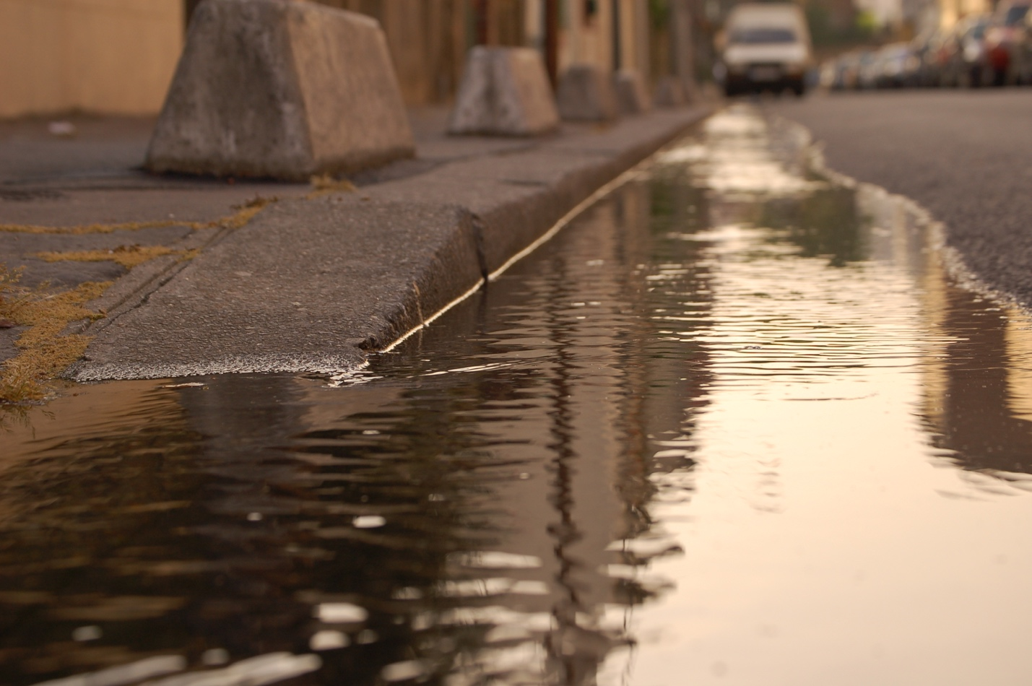
“Caniveau,” 2007. Source: Wikimedia Commons.

Course Description:

Given the many physical forms that water can take, and its central role across ecological, cultural, and economic landscapes, it’s no surprise that questions of water governance span centuries and continents. Water pours out of drinking fountains, evaporates from treetops, dilutes industrial solvents, and flows through underground aquifers. Although water is evident in a seemingly endless array of processes, conversations about water often share common themes. These include ecological responsibility, collective and privatized management, and rights for humans and non-humans alike.

Covering a broad range of perspectives on water access, this syllabus combines empirical, theoretical, geographic, and historical discussions of water with an eye towards emphasizing the breadth of relationships to, and uses of, water. Through an acknowledgement of the multiplicity of water forms that flow through landscapes and bodies, this syllabus explores the complex and shifting notions of water use and governance. At the same time, it focuses on some of the common elements and challenges which characterize these conversations. Given the persistence and escalation of struggles over water access around the world, this program of readings helps us examine both the social and physical shape of water in modern society.

The course begins with an initial overview of contemporary water access around the world, then offers a range of political and ontological perspectives on what water is and can be. In the third section, readings address histories and contemporary realities of uneven water allocation. The fourth and fifth sections, respectively, explore notions of water justice and the specificities of different forms of water in society.

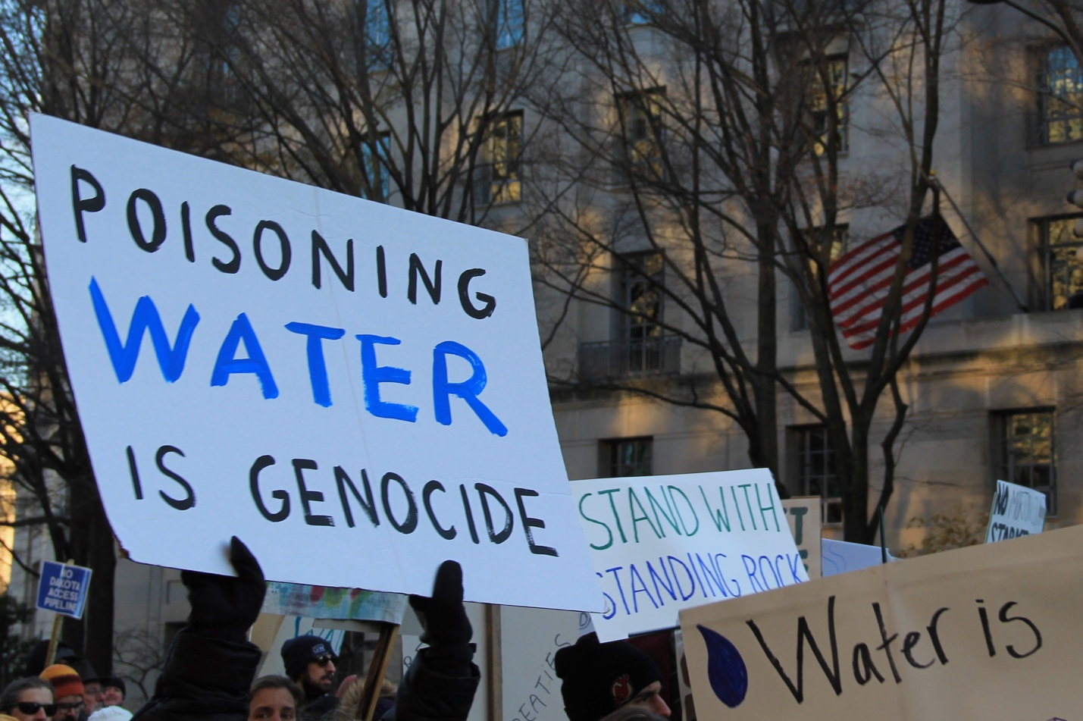
NoDAPL March on Washington, DC, 2016. Source: Wikimedia Commons.

COURSE PLAN:

Week 1: Introduction: The State of Water Today

United Nations Economic and Social Council,. Progress Towards The Sustainable Development Goals. United Nations, 2016, pp. 10-11, http://www.un.org/ga/search/view_doc.asp?symbol=E/2016/75&Lang=E.

Cooley, Heather et al. "Global Water Governance In The Twenty-First Century". The World's Water Volume 8, Peter Gleick, 1st ed., Island Press, Washington, DC, 2014, pp. 1-18,.

Dupuits, Emilie. "Technical Vs. Grassroots Experts In Global Water And Forests Governance". Alternautas, vol 2, no. 1, 2015, pp. 1-17.

Section I: Ontologies of Water Use

Week 2: The Meanings of Water

Gibbs, Leah M. "“A Beautiful Soaking Rain”: Environmental Value And Water Beyond Eurocentrism". Environment And Planning D: Society And Space, vol 28, no. 2, 2010, pp. 363-378. SAGE Publications, doi:10.1068/d9207.

Kaplan, Martha. "Lonely Drinking Fountains And Comforting Coolers: Paradoxes Of Water Value And Ironies Of Water Use". Cultural Anthropology, vol 26, no. 4, 2011, pp. 514-541. Wiley-Blackwell, doi:10.1111/j.1548-1360.2011.01110.x.

Cioc, Mark. The Rhine: An Eco-Biography. 1st ed., Seattle, Wash., University Of Washington Press, 2005,.

Wagner, John R. "Water And The Commons Imaginary". Current Anthropology, vol 53, no. 5, 2012, pp. 617-641. University Of Chicago Press, doi:10.1086/667622.

Week 3: Conceptualizing Water and Power

Alatout, Samer. "‘States’ Of Scarcity: Water, Space, And Identity Politics In Israel, 1948–59". Environment And Planning D: Society And Space, vol 26, no. 6, 2008, pp. 959-982. SAGE Publications, doi:10.1068/d1106.

Carroll, Patrick. "Water And Technoscientific State Formation In California". Social Studies Of Science, vol 42, no. 4, 2012, pp. 489-516. SAGE Publications, doi:10.1177/0306312712437977.

Budds, Jessica et al. "The Hydrosocial Cycle". Geoforum, vol 57, 2014, pp. 167-169. Elsevier BV, doi:10.1016/j.geoforum.2014.08.003.

Swyngedouw, Erik. "The Political Economy And Political Ecology Of The Hydro-Social Cycle". Journal Of Contemporary Water Research & Education, vol 142, no. 1, 2009, pp. 56-60. Wiley-Blackwell, doi:10.1111/j.1936-704x.2009.00054.x.

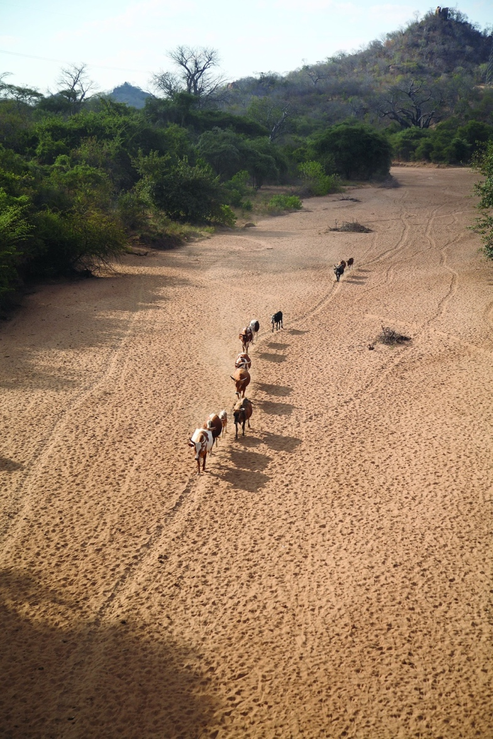
Dry river bed, Mozambique, 2008. Source: Wikimedia Commons.

Section II: Modes of Water Governance

Week 4: Historical and Contemporary Tensions in Water Governance

Bell, Martha G. "Historical Political Ecology Of Water: Access To Municipal Drinking Water In Colonial Lima, Peru (1578–1700)". The Professional Geographer, vol 67, no. 4, 2015, pp. 504-526.

Gandy, Matthew. "Landscapes Of Disaster: Water, Modernity, And Urban Fragmentation In Mumbai". Environment And Planning A, vol 40, no. 1, 2008, pp. 108-130.

Finewood, Michael H. "Green Infrastructure, Grey Epistemologies, And The Urban Political Ecology Of Pittsburgh's Water Governance". Antipode, vol 48, no. 4, 2016, pp. 1000-1021.

Bakker, Karen. "The "Commons" Versus The "Commodity": Alter-Globalization, Anti-Privatization And The Human Right To Water In The Global South". Antipode, vol 39, no. 3, 2007, pp. 430-455. Wiley-Blackwell, doi:10.1111/j.1467-8330.2007.00534.x.

Archer, Jennifer L. "Rivers, Rights & Reconciliation In British Columbia: Lessons Learned From New Zealand's Whanganui River Agreement". SSRN Electronic Journal (December 3, 2013).

Week 5: Global Economies of Water

Harris, Leila M. "Gender And Emergent Water Governance: Comparative Overview Of Neoliberalized Natures And Gender Dimensions Of Privatization, Devolution And Marketization". Gender, Place & Culture, vol 16, no. 4, 2009, pp. 387-408.

Heynen, Nik, and Paul Robbins. "The Neoliberalization Of Nature: Governance, Privatization, Enclosure And Valuation". Capitalism Nature Socialism (After Jan 1, 2004), vol 16, no. 1, 2005, pp. 5-8.

Castree, Noel. "Neoliberalising Nature: The Logics Of Deregulation And Reregulation". Environment And Planning A, vol 40, no. 1, 2008, pp. 131-152.

Perreault, Tom. "What Kind Of Governance For What Kind Of Equity? Towards A Theorization Of Justice In Water Governance". Water International, vol 39, no. 2, 2014, pp. 233-245.

Mustafa, Daanish, and Philip Reeder. "‘People Is All That Is Left To Privatize’: Water Supply Privatization, Globalization And Social Justice In Belize City, Belize". International Journal Of Urban And Regional Research, vol 33, no. 3, 2009, pp. 789-808. Wiley-Blackwell, doi:10.1111/j.1468-2427.2009.00849.x.

Mascarenhas, Michael. "Where The Waters Divide: First Nations, Tainted Water And Environmental Justice In Canada". Local Environment, vol 12, no. 6, 2007, pp. 565-577. Informa UK Limited, doi:10.1080/13549830701657265.

Week 6: In Pursuit of Water Justice: Case Studies

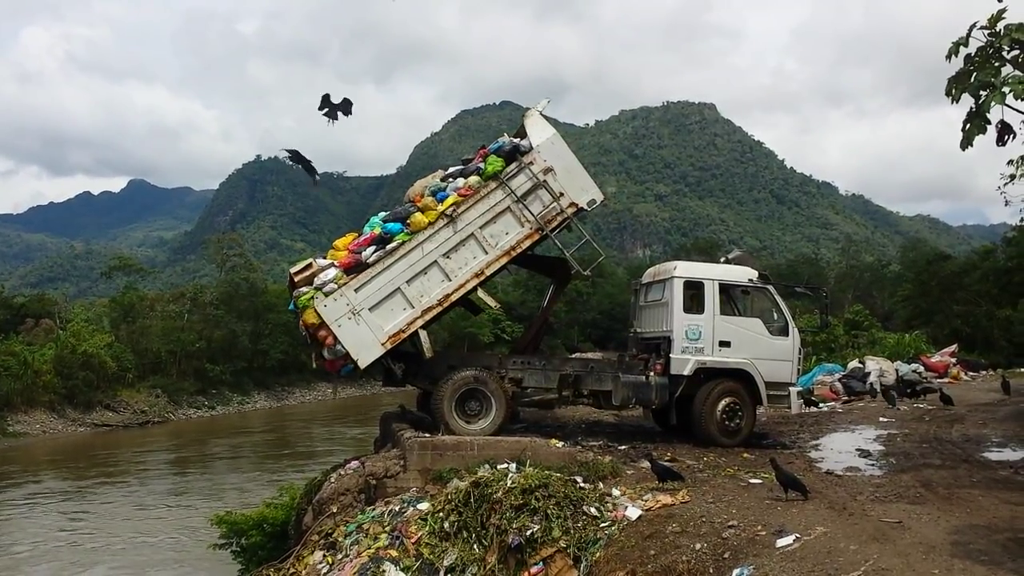
Pollution of the Huallaga River in the highlands of Peru, 2016. Source: Wikimedia Commons.

Kahimba, J, and E.P Niboye. "Grassroots Participation In Water Governance In Tanzania: The Case Of Water User Associations (Wuas) In Kimani Sub-Catchment Of The Usangu Plains". Tanzania Journal Of Development Studies, vol 8, no. 2, 2010, African Journals Online (AJOL), doi:10.4314/tjds.v8i2.60437.

McClanahan, Bill. "Green And Grey: Water Justice, Criminalization, And Resistance". Critical Criminology, vol 22, no. 3, 2014, pp. 403-418. Springer Nature, doi:10.1007/s10612-014-9241-8.

Mehta, Lyla et al. "Global Environmental Justice And The Right To Water: The Case Of Peri-Urban Cochabamba And Delhi". Geoforum, vol 54, 2014, pp. 158-166. Elsevier BV, doi:10.1016/j.geoforum.2013.05.014.

Marston, Andrea J. "Autonomy In A Post-Neoliberal Era: Community Water Governance In Cochabamba, Bolivia". Geoforum, vol 64, 2015, pp. 246-256. Elsevier BV, doi:10.1016/j.geoforum.2013.08.013.

Bullard, Robert et al. “Toxic Wastes And Race At Twenty.” The United Church Of Christ, Cleveland, OH, 2007, pp. 1-49, 152-160.

Section III: The Human-Water Interface

Week 7: dams

Themes: Global growth of mega dams, impact on communities (upstream and downstream), anti-dam activism, dam-removal movement, crumbling infrastructure

Jacques Leslie, Deep Water: The Epic Struggle over Dams, Displaced People, and the Environment (New York: Picador, 2005)

Patrick McCully, Silenced Rivers: the Ecology and Politics of Large Dams (New York: Blackwell Publishing, 2001).

Richard Stone. “Three Gorges Dam: Into the Unknown” Science, New Series, Vol. 321, No. 5889 (Aug. 1, 2008), pp. 628-632

Peter Taylor Klein, “Engaging the Brazilian State: the Belo Monte Dam and the Struggle for Political Voice,” The Journal of Peasant Studies, 2015, Vol. 42, No. 6, 1137-1156

Week 8: Irrigation and Agriculture

Sze, Julie et al. "Defining And Contesting Environmental Justice: Socio-Natures And The Politics Of Scale In The Delta". Antipode, vol 41, no. 4, 2009, pp. 807-843. Wiley-Blackwell, doi:10.1111/j.1467-8330.2009.00698.x.

Birkenholtz, Trevor. "Knowing Climate Change: Local Social Institutions And Adaptation In Indian Groundwater Irrigation". The Professional Geographer, vol 66, no. 3, 2013, pp. 354-362. Informa UK Limited, doi:10.1080/00330124.2013.821721.

Theesfeld, Insa. "Constraints On Collective Action In A Transitional Economy: The Case Of Bulgaria’S Irrigation Sector". World Development, vol 32, no. 2, 2004, pp. 251-271. Elsevier BV, doi:10.1016/j.worlddev.2003.11.001.

Mehta, Lyla et al. "Global Environmental Justice And The Right To Water: The Case Of Peri-Urban Cochabamba And Delhi". Geoforum, vol 54, 2014, pp. 158-166. Elsevier BV, doi:10.1016/j.geoforum.2013.05.014.

Week 9: Flooding and Disaster Response

Thaler, Thomas, and Thomas Hartmann. "Justice And Flood Risk Management: Reflecting On Different Approaches To Distribute And Allocate Flood Risk Management In Europe". Natural Hazards, vol 83, no. 1, 2016, pp. 129-147. Springer Nature, doi:10.1007/s11069-016-2305-1.

Dyson, Michael Eric. Come Hell Or High Water. 1st ed., New York, Basic Civitas Books, 2005,.

Salehyan, Idean. "From Climate Change To Conflict? No Consensus Yet". Journal Of Peace Research, vol 45, no. 3, 2008, pp. 315-326. SAGE Publications, doi:10.1177/0022343308088812.

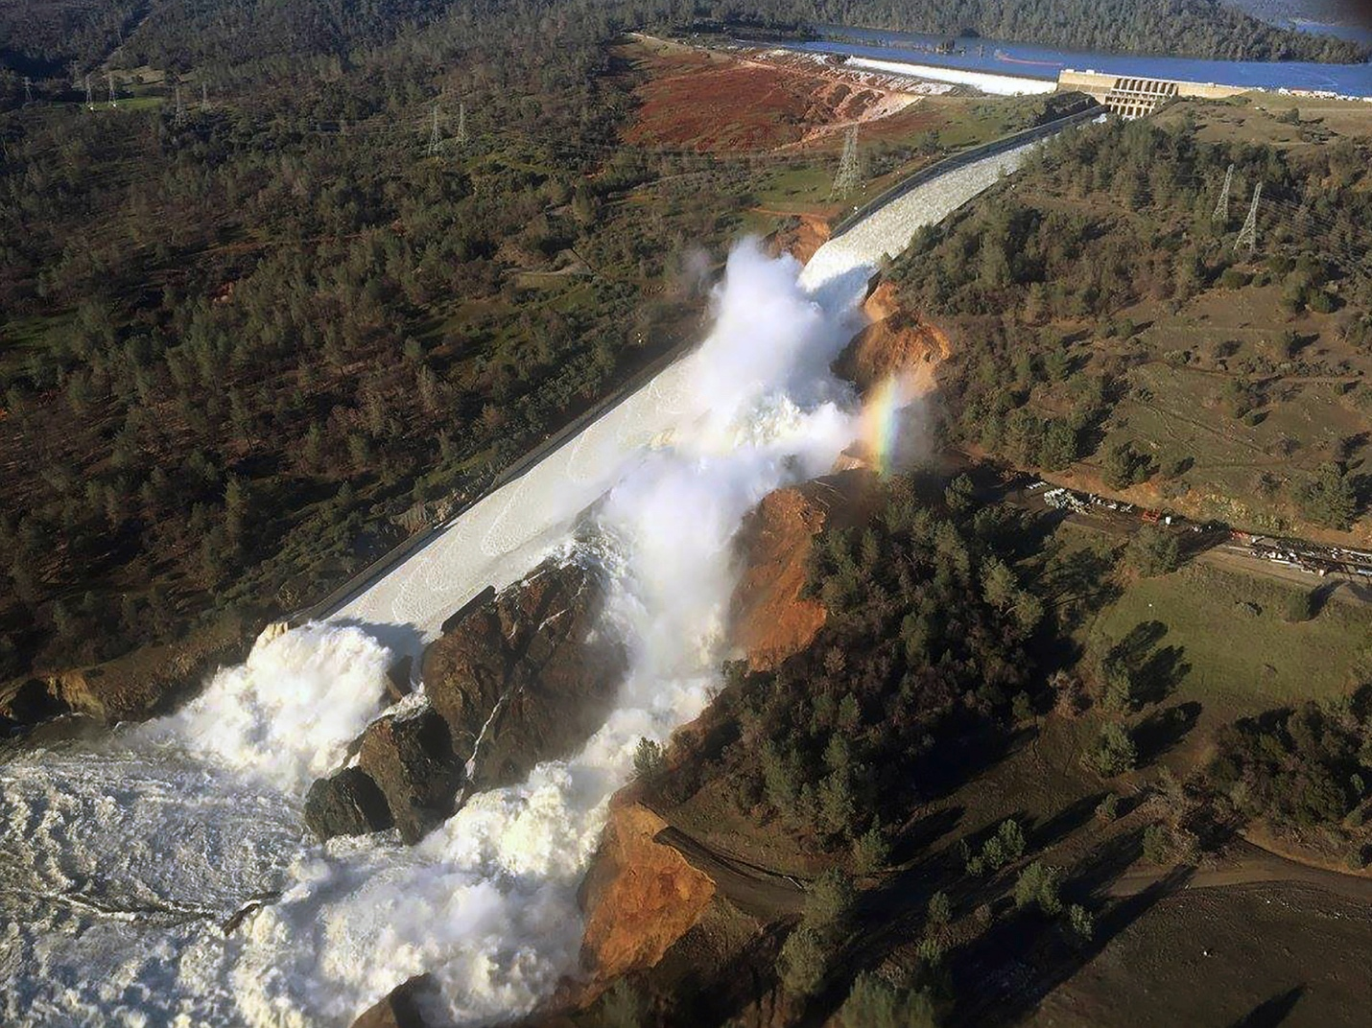
Oroville dam spillway overflow, 2017. Source: Wikimedia Commons.

Week 10: The Contamination of Groundwater, Surface Water, and Residential Water

Prudham, Scott. "Poisoning The Well: Neoliberalism And The Contamination Of Municipal Water In Walkerton, Ontario". Geoforum, vol 35, no. 3, 2004, pp. 343-359. Elsevier BV, doi:10.1016/j.geoforum.2003.08.010.

Tschakert, Petra, and Kamini Singha. "Contaminated Identities: Mercury And Marginalization In Ghana’s Artisanal Mining Sector". Geoforum, vol 38, no. 6, 2007, pp. 1304-1321. Elsevier BV, doi:10.1016/j.geoforum.2007.05.002.

Voyles, Traci Brynne. "Environmentalism In The Interstices: California's Salton Sea And The Borderlands Of Nature And Culture". Resilience: A Journal Of The Environmental Humanities, vol 3, 2016, p. 211. University Of Nebraska Press, doi:10.5250/resilience.3.2016.0211.

Sultana, Farhana. "Suffering For Water, Suffering From Water: Emotional Geographies Of Resource Access, Control And Conflict". Geoforum, vol 42, no. 2, 2011, pp. 163-172. Elsevier BV, doi:10.1016/j.geoforum.2010.12.002.

Section IV: Water Movements and Protests

Week 11: Water Protests in Historical Perspective

Barraqué, Bernard. 2012. Urban water conflicts. Paris, France: UNESCO.

Kurzman, Dan. 1987. A killing wind: inside union carbide and the Bhopal catastrophe. New York: McGraw-Hill.

Assies, Willem. "David versus Goliath in Cochabamba: water rights, neoliberalism, and the revival of social protest in Bolivia." Latin American Perspectives 30, no. 3 (2003): 14-36.

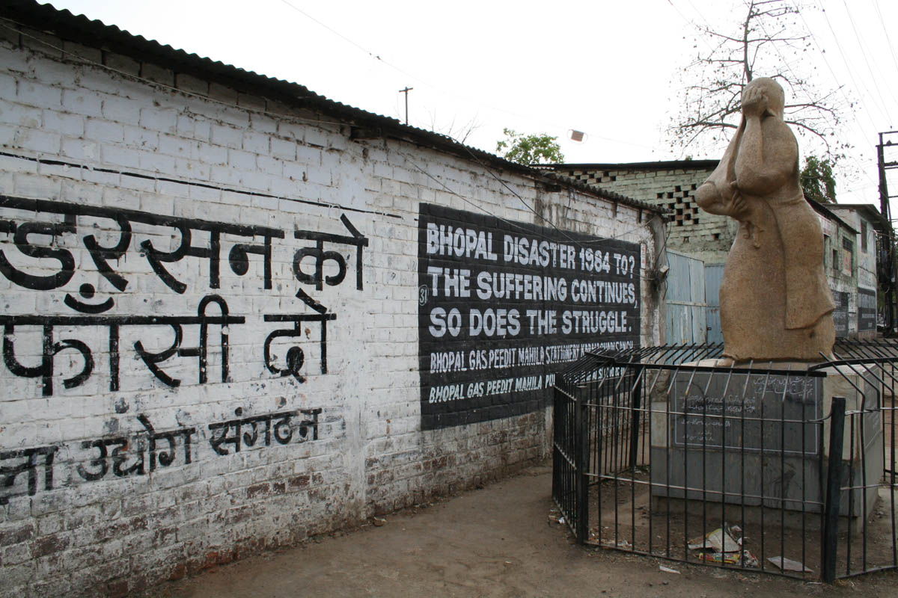
Memory site of Union Carbide disaster, Bhopal, India, 2008. Source: Wikimedia Commons.

Week 12: Water Wars

Themes: political regimes, resource privatization,

Readings: Vandana Shiva, Water Wars: Privatization, Pollution, and Profit, (North Atlantic Books, 2016)

Watch: “Leasing the Rain,” PBS Frontline Documentary on water wars in Bolivia
http://www.pbs.org/frontlineworld/stories/bolivia/thestory.html

Week 13: Water, Race, and Identity

Merrit Kennedy, “Lead-Laced Water In Flint: A Step-By-Step Look At The Makings Of A Crisis,” April 20, 2016 http://www.npr.org/sections/thetwo-way/2016/04/20/465545378/lead-laced-water-in-flint-a-step-by-step-look-at-the-makings-of-a-crisis

Evan Osnos, The Crisis in Flint Goes Deeper than the Water, January 20, 2016, http://www.newyorker.com/news/news-desk/the-crisis-in-flint-goes-deeper-than-the-water

Christopher F. Petrella, “Standing Rock, Flint, and the Color of Water,” November 2, 2016, http://www.aaihs.org/standing-rock-flint-and-the-color-of-water/

Saul Elbein, “The Youth Group That Launched a Movement at Standing Rock,” January 31, 2017 https://www.nytimes.com/2017/01/31/magazine/the-youth-group-that-launched-a-movement-at-standing-rock.html?_r=0

Charles Carlin, “Ethics of Ceremony at Standing Rock,” October 16, 2016. http://edgeeffects.net/ceremony-at-standing-rock/

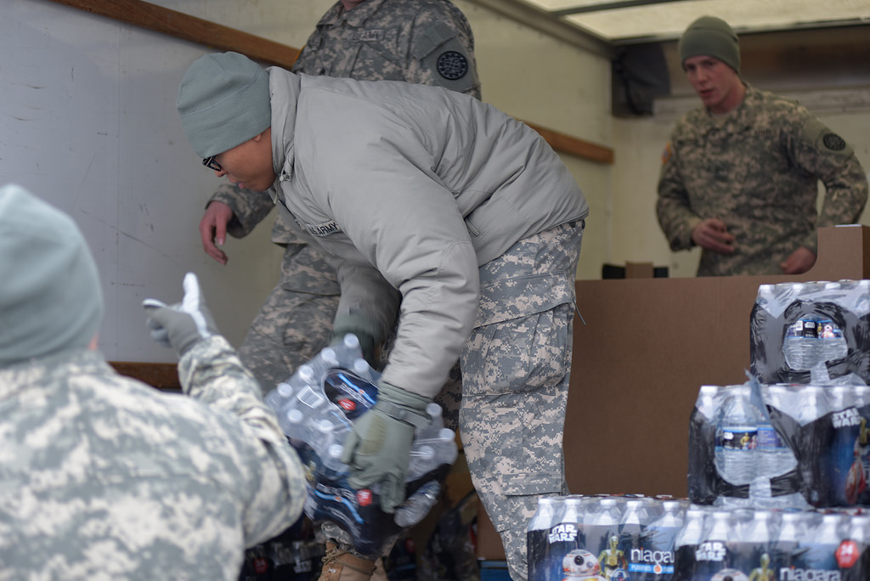
State Police Water Response Team in Flint, Michigan, 2016. Source: Flickr.

Section V: Towards Water-Just Futures

Week 14: Next Steps in Water Movements

Faber, Daniel. "Building A Transnational Environmental Justice Movement: Obstacles And Opportunities In The Age Of Globalization". Coalitions Across Borders: Transnational Protest And The Neoliberal Order, Joe Bandy and Jackie Smith, 1st ed., Rowman & Littlefield Publishers, Oxford, 2005, pp. 43-68,.

Hiskes, Richard P. "The Right To A Green Future: Human Rights, Environmentalism, And Intergenerational Justice". Human Rights Quarterly, vol 27, no. 4, 2005, pp. 1346-1364. Johns Hopkins University Press, doi:10.1353/hrq.2005.0049.

Martínez-Alier, Joan. "Environmental Justice And Economic Degrowth: An Alliance Between Two Movements". Capitalism Nature Socialism, vol 23, no. 1, 2012, pp. 51-73. Informa UK Limited, doi:10.1080/10455752.2011.648839.

Week 15: Adapting to Future Challenges

Watch: "Our Mission". Alliance For Water Justice In Palestine, 2017, http://waterjusticeinpalestine.org/mission/.

"Waterjustice". Waterjustice.Org, 2017, http://www.waterjustice.org/?mi=1&theme=3.

"Water And Environmental Justice - Pacific Institute". Pacific Institute, 2017, http://pacinst.org/issues/sustainable-water-management-local-to-global/water-and-environmental-justice/

Water drop, 2012. Source: Wikimedia Commons.

